Create the database to manages all products in shop with the name ProductsManagement , including three tables : Users , Products , Categories.

Table: | Categories
Column | Description
CategoryID | Category code
CategoryName | Name of category
Table: | Users
Column | Description
UserName | User Name
Password | Password
Table: | Products
Column | Description
ProductID | Product Code
ProductName | Name of Product
CategoryID | Category code
Price | Price
QuantityPerUnit | Quantity per unit

- Create a new Winform project.  - Create a MDI form as following.  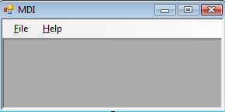  - Create Menu as: (2 marks)  - When the user click on the:  - Login menu item, show the Login form  - View Products menu item, show the Products form  - About menu item, show the About form  - Exit menu item, end the program | - Create Login form as following:  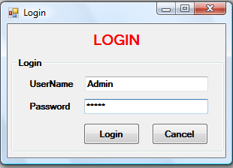  - When the user clicked the OK button. The following validations must be performed:  - The Textboxes can not be blank.  - Check the UserName and Password below database. If they exist in the database, show MDI form and then close the Login form  - If the UserName or Password is not correct, clear all textboxes and show a message “ UserName or Password incorrect ! “ to inform the user.
  File | Login
  File | View Products
  File | Exit
  Help | About
- Create the MDI child Orders form as below:
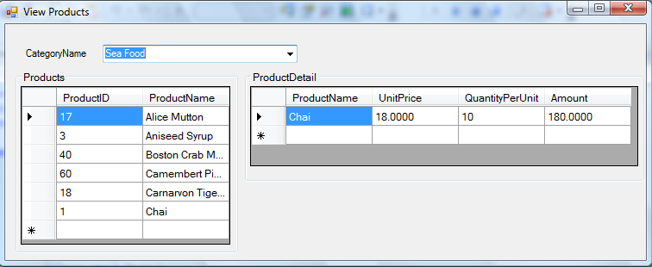

- Functions of the form :
- When the form is loaded, populate Combobox with CategoryName from Categories table. (4 marks)

- When the user select a CategoryName from Combobox, all Products (from Products table with ProductID, ProductsName fields) of that Products must be shown in the DataGrid on the left of the form. (5 marks)

- When the user select an Product from the Prodcuts list, all details (ProductName, UnitPrice, QuantityPerUnit and Amount fields (Amount=UnitPrice*QuantityPerUnit)) of that Product must be shown in the DataGrid on the right of the form.
- Create About form as:



- Insert the image into the form (any images) and the Close button.
- Write code to close the form when the user click on the Close button.

